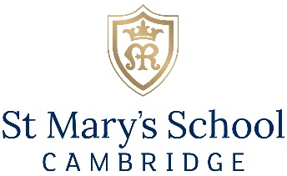

Thank you for your request for further details of this position.
Candidates should complete the Application Form and Equal Opportunities Form which can be found on the Vacancies page of our website. Parts 5 and 6 of the Application Form must show a complete history of employment and should continue on a separate sheet if necessary. These should be emailed together to the HR department hr@stmaryscambridge.co.uk .
Applications will be reviewed on receipt so early submission is advisable. The school's preferred method of communication is by email and it will not be necessary to send a hard copy of the documents by post. St Mary’s School, Cambridge is committed to the safeguarding of pupils and promoting the welfare of children and young people and expects all staff and volunteers to share this commitment. Applicants will be required to undergo child protection screening appropriate to the post, including checks with past employers and the Disclosure and Barring Service (DBS) Any offer of employment will be subject to an enhanced DBS disclosure, the receipt of satisfactory references and the school’s pre-employment medical questionnaire, right to work in the UK, relevant original ID documentation and degree certificate(s). Interviews will be conducted in person, and they will explore candidates’ suitability to work with children. A copy of our Safeguarding Policy can be found on the Vacancies page of our website.
The post is exempt from the Rehabilitation of Offenders Act 1974 and the School is therefore permitted to ask all shortlisted applicants to declare all convictions and cautions (including those which are "spent" unless they are "protected" under the DBS filtering rules) in order to assess their suitability to work with children.
Interviews will be conducted in person, and they will explore candidates’ suitability to work with children. Candidates are required to bring with them the necessary ID documentation and any relevant qualification certificate(s), all of which must be originals. Further information of the interview format will be provided if you are shortlisted for interview.
St Mary’s School, Cambridge is an inner-city school, with no parking.
To find out more about the school, please visit www.stmaryscambridge.co.uk
If you have any queries or would like any additional information, please email Megan Hill hr@stmaryscambridge.co.uk

